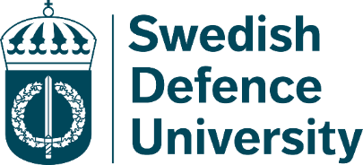

Multiplier Event & Conference
27-28 October 2022
Venue: Drottning Kristinas väg 37 Rooms: Cardell and Raab
Thursday October 27th
09.00 | Registration
10.00 | Opening session: Deputy Vice-chancellor, BG, Anders Persson
10.15 | Keynote speaker: Pro-Dean, Cdr, Stefan Lundqvist Ph.D.  From Partner to Ally: Taking Language Seriously
10.45 | Coffee break
11.15 | Presentation: Erasmus+ Strategic Partnership project - Hybridsation of Specialised English Learning for Security professionals HELPSec
12.00 | Lunch (provided by The Swedish Defence University) at the restaurant Propellern
13.00 | Poster session:  Annette Nolan, Lecturer, Swedish Defence University (SEDU)  Lynda Hanson Wood, Lecturer, Royal Danish Military Academy/Royal Defence College (RDC)  Kåre Kildevang, Professor, Royal Danish Military Academy/Royal Defence College (RDC)  Carina Gossas, Senior Lecturer, Swedish Armed Forces, Interpreter School
14.30 | Coffee break
15.00 | Workshops - HELPSec
16.30 | End of the first day
17.30 | Mingle and dinner (Restaurant Propellern, Hosted by The Language Division)

Friday October 28th
09.00 | Keynote speaker: Lecturer Keith Farr  Backward Planning
09.30 | Keynote speaker: Senior Lecturer Stellan Sundh  International Collaborations
10.00 | Coffee break
10.30 | Poster session :  Jacqueline Anwar, Lecturer, Swedish Defence University (SEDU)  Stijn Simkens, Lecturer, Swedish Defence University (SEDU)  Birgitte Grande, Lecturer, Norwegian Defence University College, (NDUC)  Diana Nilsson, Lecturer, Swedish Defence University (SEDU)
13.00 | Closing session

